Performance Testing
Date | 12 July 2026
Team ID | AIML-HDI-2026
Project Name | A Comprehensive Measure of Well-Being
Maximum Marks | 5 Marks

Performance Testing
Performance testing evaluates how the system behaves under expected and peak load conditions, and how accurate the trained model is. The sections below document the testing approach, tools used, and results obtained.

Step 1: Testing Overview
Field | Details
Testing Tool Used | Manual browser testing of the Flask dashboard; scikit-learn metrics for model evaluation.
Type of Testing | Functional testing, model performance testing, and user acceptance testing.
Target Module / API | HDI prediction endpoint (Flask form submission → model inference → result render).
Test Environment | Kaggle Notebook GPU runtime, tunnelled publicly via LocalTunnel.
Test Date | 12 July 2026

Step 2: Model Performance Test Results
S.No | Metric | Target Value | Actual Value | Status | Remarks
1 | Mean Absolute Error (MAE) | ≤ 0.03 | 0.02640 | Pass | Regression error well within target on held-out test split.
2 | Root Mean Squared Error (RMSE) | ≤ 0.04 | 0.03113 | Pass | Consistent with the low MAE; no large outlier errors.
3 | Tier Classification Accuracy | ≥ 80% | 83% | Pass | Verified on test set (n = 141) across 4 tiers.
4 | Macro Avg. F1-score | ≥ 0.75 | 0.83 | Pass | “High” tier shows the most confusion with “Very High” near the boundary.
5 | Training Convergence | Stable by epoch 20 | Stable ~epoch 10–20 | Pass | Train/validation loss curves converge closely, indicating low overfitting.

Step 3: Functional & User Acceptance Testing
S.No | Test Case | Steps | Expected Result | Status
1 | Web form loads correctly | Open the LocalTunnel dashboard URL in a browser. | Form renders with 3 numeric input fields and default values. | Pass
2 | Valid input prediction | Enter Life Expectancy, Schooling, and GNI within valid ranges and submit. | Predicted HDI score and colour-coded tier badge display within seconds. | Pass
3 | Boundary tier value | Enter values expected to produce a score near a tier boundary (e.g., ~0.70). | Correct tier (High vs Medium) is assigned per threshold rule. | Pass
4 | Repeated submissions | Submit the form multiple times with different values in the same session. | Each submission returns an updated prediction without server restart. | Pass
5 | Session stability | Keep the LocalTunnel session open for the duration of the demo. | Application remains reachable and responsive throughout. | Pass

Step 4: Observations & Analysis
Key Findings: The dual-branch hybrid model converges quickly (within the first 10–20 of 120 epochs) and generalizes well, with training and validation loss curves tracking closely throughout. The web dashboard returns predictions with no perceptible delay for a single user during manual testing.
Bottlenecks Identified: The primary limitation is the “High” tier's precision (0.63), where the regression output near tier boundaries is occasionally over-classified from adjacent tiers — an expected outcome of applying hard thresholds to a continuous prediction.
Optimization Steps Taken: Feature scaling (Min-Max normalization) was fit only on the training split and reused at inference time to avoid data leakage; the trained model and scaler were serialized separately so that inference does not require retraining.

Step 5: Screenshots / Evidence
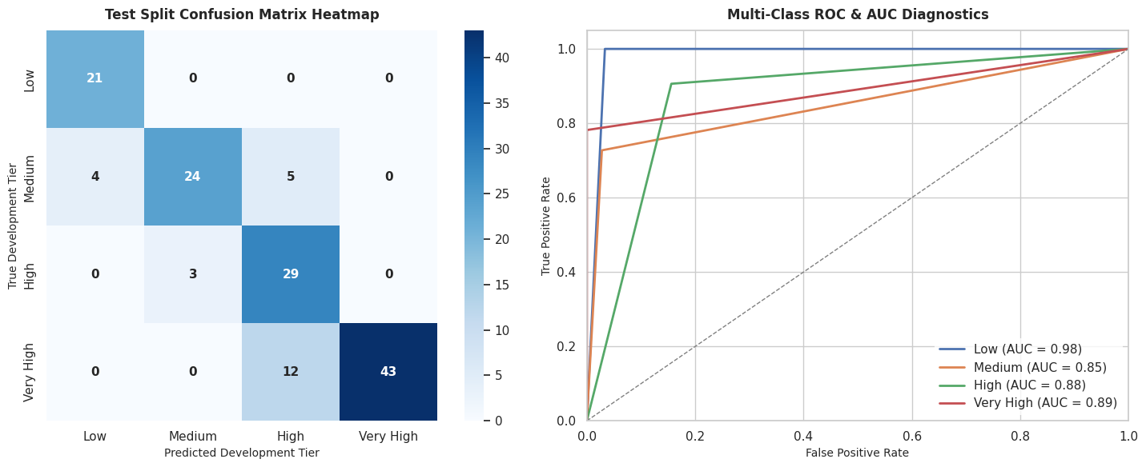
Figure: Test-set confusion matrix and multi-class ROC-AUC diagnostics, confirming the performance figures reported above.

